Databases

From Data Variables to Databases: A Beginner's Journey

👋 Introduction
Hey students! In this lesson, we’ll take a fun and practical journey — from simple data in JavaScript to using a real database that apps like Instagram, YouTube, or games use to store millions of users and their data.

📦 1. What is Data?

🧠 Real-Life Example:
Imagine you're keeping track of your favorite songs:
- Song name: "Believer"
- Artist: "Imagine Dragons"
- Duration: 204 seconds

💻 In JavaScript:
let songName = "Believer";
let artist = "Imagine Dragons";
let duration = 204;

Each variable stores one piece of data.

🧺 2. Grouping Related Data: Objects

🤔 Problem:
What if you want to store multiple details about one song in one place?

✅ Solution: Use an Object
let song = {
name: "Believer",
artist: "Imagine Dragons",
duration: 204
};

📋 3. Handling Many Items: Arrays of Objects

🎧 Example: Playlist of songs
let playlist = [
{
name: "Believer",
artist: "Imagine Dragons",
duration: 204
},
{
name: "Blinding Lights",
artist: "The Weeknd",
duration: 200
}
];

Now you can store many songs together and work with them easily.

🌐 4. Saving Data: JSON Format

💡 What is JSON?
JSON stands for JavaScript Object Notation — a text format to store and send data.
let jsonData = JSON.stringify(playlist);
console.log(jsonData);

You can send this to other apps, store in files, or even use it in a database!

💾 5. Storing Data Temporarily: Local Storage (Browser)

🧪 Example:
localStorage.setItem("myPlaylist", JSON.stringify(playlist));

let savedData = localStorage.getItem("myPlaylist");
let songs = JSON.parse(savedData);
console.log(songs);

This is useful for small apps, but it won’t last forever or work well for multiple users.

📁 6. Saving Data in Files (Node.js)

✏️ Write and Read File:
const fs = require('fs');
// Save
fs.writeFileSync("playlist.json", JSON.stringify(playlist));
// Load
let data = fs.readFileSync("playlist.json");
let playlistFromFile = JSON.parse(data);
console.log(playlistFromFile);

This is better than localStorage but still has limitations: it's slow with large data and not great with many users.

🚧 7. Why Files Are Not Enough
Let’s imagine your app grows. You now have:
- Hundreds of users
- Thousands of songs
- Multiple people using your app at once
Here’s what goes wrong with files:
Problem | Why it’s bad
💥 Files get overwritten | If two users try to write at the same time, one may lose data
🐢 Slow with large data | Reading/writing big JSON files gets slow
🧩 No easy search | You can’t easily find songs by artist or ID
🔒 No user access control | Can’t give different users access to different data
❌ Not scalable | Hard to organize, manage, and grow over time
🔑 Conclusion: For apps with lots of data and users, we need something faster, safer, and smarter.

🏛️ 8. What is a Database?
A database is like a super-smart digital notebook that:
- Stores structured data
- Organizes it in tables (like Excel)
- Lets you search, add, delete, update fast
- Works with many users at the same time
- Is used by real-world apps like WhatsApp, Spotify, YouTube, etc.

🧠 Example in Real Life
App | What it stores in a database
YouTube | Videos, users, comments
Instagram | Posts, likes, followers
Spotify | Songs, albums, playlists
Gmail | Emails, contacts

📊 10. Tables in Databases (Relational DB)
Tables in databases look like spreadsheets.
Id | Name | Artist | Duration
1 | Believer | Imagine Dragons | 204
2 | Blinding Lights | The Weeknd | 200
- Each row = one song
- Each column = a property (field) of the song

⚙️ 11. Using PostgreSQL to Understand Relational Databases
Now that we understand why we need databases, let’s dive into a real relational database:

👉 PostgreSQL
It’s powerful, widely used, and perfect for building real-world apps.

🛠️ PostgreSQL Setup Instructions (Complete – Windows, macOS, Linux)

✅ Step 1: Install PostgreSQL
- Windows: Download from https://www.postgresql.org/download/, https://www.pgadmin.org/download/
- Mac: Use Homebrew
brew install postgresql
- Linux (Ubuntu):
sudo apt update
sudo apt install postgresql postgresql-contrib

✅ Step 2: Start PostgreSQL
sudo service postgresql start

✅ Step 3: Enter PostgreSQL CLI
sudo -u postgres psql

✅ Step 4: Create a New Database and User
CREATE DATABASE musicdb;
CREATE USER musicuser WITH ENCRYPTED PASSWORD 'musicpass';
GRANT ALL PRIVILEGES ON DATABASE musicdb TO musicuser;

🎉 You now have a database called musicdb and a user musicuser.

🧑‍💻 Step 5: Connect Node.js to PostgreSQL
Install the PostgreSQL driver:
npm install pg

📄 Example Code (Create Table, Insert, Fetch Songs)
const { Client } = require('pg');
const client = new Client({
user: 'musicuser',
host: 'localhost',
database: 'musicdb',
password: 'musicpass',
port: 5432,
});
async function main() {
await client.connect();
// Create table if not exists
await client.query(`
CREATE TABLE IF NOT EXISTS songs (
id SERIAL PRIMARY KEY,
name TEXT,
artist TEXT,
duration INTEGER
);
`);
// Insert a song
await client.query(
'INSERT INTO songs (name, artist, duration) VALUES ($1, $2, $3)',
['Believer', 'Imagine Dragons', 204]
);
// Fetch all songs
const res = await client.query('SELECT * FROM songs');
console.log(res.rows);
await client.end();
}
main();

🧠 What Just Happened?
- Connected to PostgreSQL using Node.js
- Created a songs table
- Inserted one song record
- Fetched all rows
Relational databases like PostgreSQL:
- Store data in tables
- Allow relationships (e.g., users & playlists)
- Make querying data super fast and powerful

🔄 12. Comparing File vs Database (PostgreSQL)
Feature | Files (JSON) | Database (SQLite)
Store structured data | ✅ | ✅
Handle big data | ❌ Slow | ✅ Fast
Multiple users | ❌ Risky | ✅ Safe
Search/filter data | ❌ Manual | ✅ With SQL
Auto-increment ID | ❌ Manual | ✅ Built-in
Data relationships | ❌ Difficult | ✅ Easy (tables, joins)
📊 Real-world scalability | ❌ | ✅ Used by Netflix, Facebook
💡 TL;DR: Files are fine for beginners, but relational databases like PostgreSQL are made for real apps.

✅ Summary So Far
- We started from variables
- Moved to arrays and objects
- Then stored data in files
- Learned why files are not enough
- Introduced databases
- Learned how to use PostgreSQL with Node.js
- Compared files vs relational DBs

Normalization

🧠 From Messy Tables to Clean Databases: Understanding Normalization

✨ A Beginner’s Guide to First, Second, and Third Normal Forms
👋 Introduction
Hey students! Ready to level up your database skills? Today we’ll talk about normalization — a fancy word that just means organizing your data in a smarter way so your app stays fast, clean, and easy to manage.
🎯 We’ll explain:
- Why normalization matters
- The 3 most important types: 1NF, 2NF, and 3NF
- Real-world examples (songs, artists, playlists!)
- Simple diagrams to help you see the difference

💥 1. What’s the Problem? (Unnormalized Data)
Let’s say you start with this simple table of songs:
ID | Song Name | Artist Name | Artist Instagram | Album Name | Album Year
1 | Believer | Imagine Dragons, 204 | @imaginedragons | Evolve | 2017
2 | Blinding Lights | The Weeknd, 200 | @theweeknd | After Hours | 2020
3 | Radioactive | Imagine Dragons, 210 | @imaginedragons | Night Visions | 2012
🤔 Looks fine, right? But there are problems:
- Mixed values in a record
- Artist info is repeated multiple times
- If an artist changes their Instagram handle, you’ll have to update it everywhere
- You can accidentally make typos like @imaginedrag0ns
We need to normalize the data to remove duplication, reduce errors, and make changes easier.

📶 2. First Normal Form (1NF)
🎯 Goal: Make sure each column has atomic (indivisible) values and all records are unique.
🧠 Fixes:
- No repeating groups
- No multiple values in one column
- Each row should represent one thing
ID | Song Name | Artist | Duration | Artist Instagram
1 | Believer | Imagine Dragons | 204 | @imaginedragons
2 | Blinding Lights | The Weeknd | 200 | @theweeknd
3 | Radioactive | Imagine Dragons | 210 | @imaginedragons
✅ Already atomic. Each field holds one value.
But… artist info is still repeated. That’s where 2NF comes in.

🧠 Class Diagram for 1NF
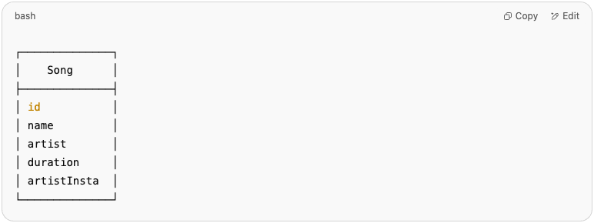

🛑 Repeating artist information for every song = not ideal for long-term scaling.

📈 3. Second Normal Form (2NF)
🎯 Goal: Move repeated data to a separate table and link them with a key.
We split Songs and Artists:

🎧 Songs Table
Song ID | Name | Duration | Artist ID
1 | Believer | 204 | 1
2 | Blinding Lights | 200 | 2
3 | Radioactive | 210 | 1

🎤 Artists Table
Artist ID | Name | Instagram
1 | Imagine Dragons | @imaginedragons
2 | The Weeknd | @theweeknd
🙌 Now, each artist is stored only once, and songs point to them using artistId.

🧠 Class Diagram for 2NF
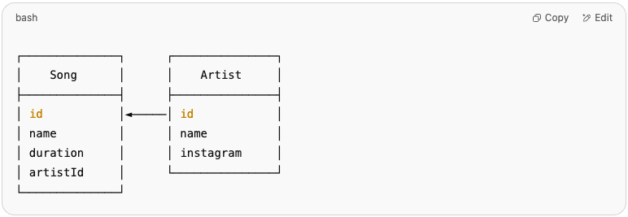

💡 artistId creates a relationship between Song and Artist.

🧹 4. Third Normal Form (3NF)
🎯 Goal: Remove columns that don’t depend directly on the primary key.
Let’s add another column to Songs: albumName and albumReleaseYear
Song ID | Name | Duration | Artist ID | Album Name | Album Year
1 | Believer | 204 | 1 | Evolve | 2017
2 | Blinding Lights | 200 | 2 | After Hours | 2020
3 | Radioactive | 210 | 1 | Night Visions | 2012
🛑 Problem: Album data is repeating and not directly related to the song’s ID — it's related to the album.
✅ Fix: Create an Albums table.

🎵 Songs Table (3NF)
Song ID | Name | Duration | Album ID
1 | Believer | 204 | 1
2 | Blinding Lights | 200 | 2
3 | Radioactive | 210 | 3

💿 Albums Table
Album ID | Name | Year | Artist ID
1 | Evolve | 2017 | 1
2 | After Hours | 2020 | 2
3 | Night Visions | 2012 | 1
🙌 Now each table stores only the data it owns, and foreign keys keep everything connected.

🧠 Class Diagram for 3NF
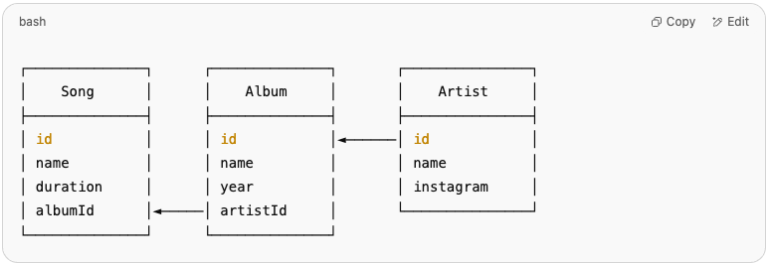

🎉 Every table does one job, and data is not duplicated anywhere.

✅ Summary: Normalize Like a Pro
Normal Form | Fixes This Issue | What You Do
1NF | Repeating groups, non-atomic values | Make each field atomic
2NF | Redundant data across rows | Move repeating data to new table
3NF | Indirect dependencies | Split data into more focused tables

🔁 Real-World Benefits
- 🚀 Faster queries
- ❌ Fewer bugs
- ✨ Easier updates
- 🧼 Cleaner code & structure
- 💪 Scalable for big apps

Entity Relationship Diagram

🎯 Relationships Between Tables

💡 A Beginner’s Guide to Using ERD diagram

🔍 What is ERD?
An Entity Relationship (ER) Diagram is a type of flowchart that illustrates how “entities” such as people, objects or concepts relate to each other within a system.
ER Diagrams are most often used to design or debug relational databases in the fields of software engineering, business information systems, education and research.

🧱 What’s Happening Here?
Let’s visualize it:

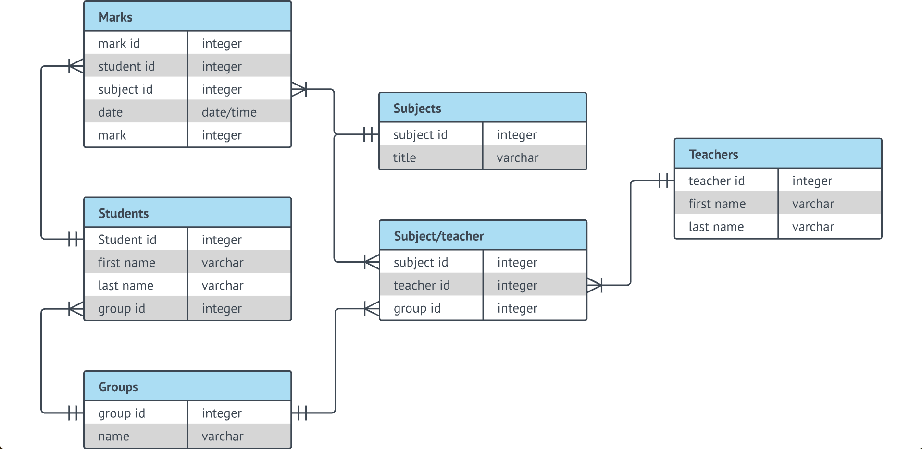

🎯 Relationships symbols
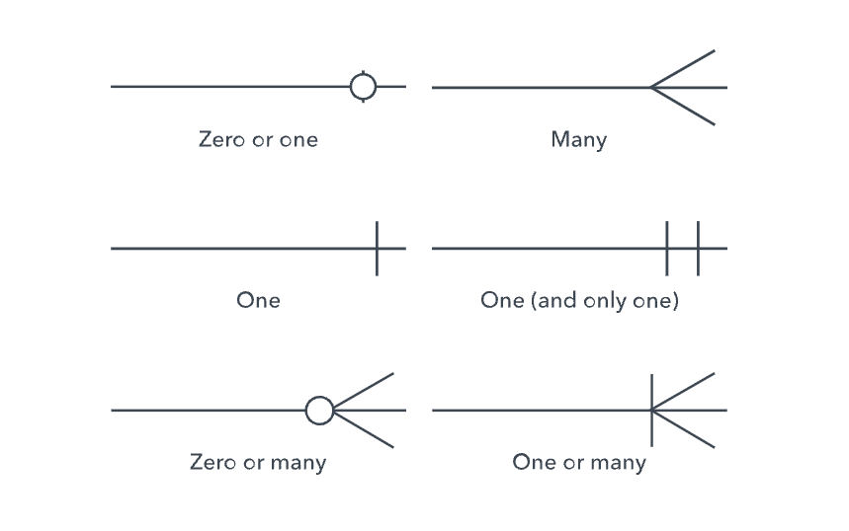

🎯 Create Tables
CREATE TABLE IF NOT EXISTS artist(
id SERIAL PRIMARY KEY,
name TEXT,
instagram TEXT
);

CREATE TABLE IF NOT EXISTS album (
id SERIAL PRIMARY KEY,
name TEXT,
year INTEGER,
artistId INTEGER,
CONSTRAINT fk_artist
FOREIGN KEY (artistId)
REFERENCES artist(id)
ON DELETE CASCADE
);

CREATE TABLE IF NOT EXISTS song (
id SERIAL PRIMARY KEY,
name TEXT,
duration INTEGER,
albumId INTEGER,
CONSTRAINT fk_album
FOREIGN KEY (albumId)
REFERENCES album(id)
ON DELETE CASCADE
);

🎯 Insert Data Into Tables
INSERT INTO artist (name, instagram) VALUES ('Imagine Dragons', '@imaginedragons');
INSERT INTO artist (name, instagram) VALUES ('The Weekend', '@theweekend');

INSERT INTO album (name, year, artistId) VALUES ('Evolve', 2017, 1);
INSERT INTO album (name, year, artistId) VALUES ('After Hours', 2020, 2);

INSERT INTO song (name, duration, albumId) VALUES ('Believer', 204, 1);
INSERT INTO song (name, duration, albumId) VALUES ('Blinding Lights', 200, 2);

🎯 Fetch Data From Multiple Tables
SELECT
song.name AS song_name,
song.duration,
album.name AS album_name,
album.year AS album_year,
artist.name AS artist_name
FROM song
JOIN album ON song.albumId = album.id
JOIN artist ON album.artistId = artist.id;

💡Resources
- What is an Entity Relationship Diagram (ERD)?

ORM

🎯 From Tables to Code: ORM and Sequelize Explained

💡 A Beginner’s Guide to Using ORM in Node.js Projects with Sequelize

👋 What’s This All About?
Let’s say you’ve learned how to design a clean database using normalization (1NF, 2NF, 3NF).
Now it’s time to talk to that database from your code.
This is where ORM steps in.

🔍 What is ORM?
Object Relational Mapping (ORM) is a way to treat your database tables like JavaScript objects.
It saves you from writing raw SQL manually and helps keep your code cleaner, safer, and easier to manage.

🤖 Sequelize: The ORM for Node.js
Sequelize is a powerful ORM for Node.js. It lets you:
- Define tables as models
- Run queries as JavaScript code
- Generate tables using migrations
- Manage relationships between tables

🧠 Let’s Start With a Simple Example
You want to store Artists, Albums and Songs, just like in the normalization guide.

Artist Table
Artist ID | Name | Instagram
1 | Imagine Dragons | @imaginedragons
2 | The Weeknd | @theweeknd

Album Table
Album ID | Name | Year | Artist ID
1 | Evolve | 2017 | 1
2 | After Hours | 2020 | 2
3 | Night Visions | 2012 | 1

Song Table
Song ID | Name | Duration | Album ID
1 | Believer | 204 | 1
2 | Blinding Lights | 200 | 2
3 | Radioactive | 210 | 3

1️⃣ Initialize Sequelize In Project
npx sequelize-cli init

2️⃣ Define the Models with Sequelize

models/Artist.js
// models/artist.js
module.exports = (sequelize, DataTypes) => {
const Artist = sequelize.define("Artist", {
id: {
type: DataTypes.UUID,
defaultValue: DataTypes.UUIDV4,
primaryKey: true
},
name: {
type: DataTypes.STRING,
allowNull: false
},
instagram: {
type: DataTypes.STRING,
allowNull: false
}
});

Artist.associate = models => {
Artist.hasMany(models.Album, { foreignKey: "artistId" });
Artist.hasMany(models.Song, { foreignKey: "artistId" });
};

return Artist;
};

models/Album.js
// models/album.js
module.exports = (sequelize, DataTypes) => {
const Album = sequelize.define("Album", {
id: {
type: DataTypes.UUID,
defaultValue: DataTypes.UUIDV4,
primaryKey: true
},
name: {
type: DataTypes.STRING,
allowNull: false
},
year: {
type: DataTypes.INTEGER
}
});

Album.associate = models => {
Album.belongsTo(models.Artist, { foreignKey: "artistId" });
Album.hasMany(models.Song, { foreignKey: "albumId" });
};

return Album;
};

models/Song.js
// models/song.js
module.exports = (sequelize, DataTypes) => {
const Song = sequelize.define("Song", {
id: {
type: DataTypes.UUID,
defaultValue: DataTypes.UUIDV4,
primaryKey: true
},
name: {
type: DataTypes.STRING,
allowNull: false
},
duration: {
type: DataTypes.INTEGER // in seconds
}
});

Song.associate = models => {
Song.belongsTo(models.Album, { foreignKey: "albumId" });
Song.belongsTo(models.Artist, { foreignKey: "artistId" });
};

return Song;
};

3️⃣ Creating Tables with Migrations
Instead of syncing models directly (which is risky in production), we use migrations.

Run
npx sequelize-cli migration:generate --name enable-uuid

Example: migrations/XXXXXX-enable-uuid.js
module.exports = {
up: (queryInterface) => queryInterface.sequelize.query('CREATE EXTENSION IF NOT EXISTS "uuid-ossp";'),
down: (queryInterface) => queryInterface.sequelize.query('DROP EXTENSION IF EXISTS "uuid-ossp";')
};

Run
npx sequelize-cli migration:generate --name create-artist

Example: migrations/XXXXXX-create-artist.js
'use strict';

module.exports = {
up: async (queryInterface, Sequelize) => {
await queryInterface.createTable('Artists', {
id: {
type: Sequelize.UUID,
defaultValue: Sequelize.literal('uuid_generate_v4()'),
primaryKey: true,
allowNull: false
},
name: {
type: Sequelize.STRING,
allowNull: false
},
createdAt: {
allowNull: false,
type: Sequelize.DATE,
defaultValue: Sequelize.literal('NOW()')
},
updatedAt: {
allowNull: false,
type: Sequelize.DATE,
defaultValue: Sequelize.literal('NOW()')
}
});
},

down: async (queryInterface) => {
await queryInterface.dropTable('Artists');
}
};

Run
npx sequelize-cli migration:generate --name create-album

Example: migrations/XXXXXX-create-album.js
'use strict';

module.exports = {
up: async (queryInterface, Sequelize) => {
await queryInterface.createTable('Albums', {
id: {
type: Sequelize.UUID,
defaultValue: Sequelize.literal('uuid_generate_v4()'),
primaryKey: true,
allowNull: false
},
name: {
type: Sequelize.STRING,
allowNull: false
},
year: {
type: Sequelize.INTEGER
},
artistId: {
type: Sequelize.UUID,
allowNull: false,
references: {
model: 'Artists',
key: 'id'
},
onUpdate: 'CASCADE',
onDelete: 'CASCADE'
},
createdAt: {
allowNull: false,
type: Sequelize.DATE,
defaultValue: Sequelize.literal('NOW()')
},
updatedAt: {
allowNull: false,
type: Sequelize.DATE,
defaultValue: Sequelize.literal('NOW()')
}
});
},

down: async (queryInterface) => {
await queryInterface.dropTable('Albums');
}
};

Run
npx sequelize-cli migration:generate --name create-song

Example: migrations/XXXXXX-create-song.js
'use strict';

module.exports = {
up: async (queryInterface, Sequelize) => {
await queryInterface.createTable('Songs', {
id: {
type: Sequelize.UUID,
defaultValue: Sequelize.literal('uuid_generate_v4()'),
primaryKey: true,
allowNull: false
},
name: {
type: Sequelize.STRING,
allowNull: false
},
duration: {
type: Sequelize.INTEGER
},
albumId: {
type: Sequelize.UUID,
allowNull: false,
references: {
model: 'Albums',
key: 'id'
},
onUpdate: 'CASCADE',
onDelete: 'CASCADE'
},
artistId: {
type: Sequelize.UUID,
allowNull: false,
references: {
model: 'Artists',
key: 'id'
},
onUpdate: 'CASCADE',
onDelete: 'CASCADE'
},
createdAt: {
allowNull: false,
type: Sequelize.DATE,
defaultValue: Sequelize.literal('NOW()')
},
updatedAt: {
allowNull: false,
type: Sequelize.DATE,
defaultValue: Sequelize.literal('NOW()')
}
});
},

down: async (queryInterface) => {
await queryInterface.dropTable('Songs');
}
};

4️⃣ Run Your Migrations
npx sequelize-cli db:migrate

✅ This creates real PostgreSQL tables behind the scenes.

4️⃣ Insert and Query Data Like a Pro
const express = require("express");
const { Sequelize } = require("sequelize");
const { Artist, Album, Song } = require("./models");

const app = express();
app.use(express.json());

// Initialize Sequelize (adjust credentials to match your config)
const sequelize = new Sequelize("postgres", "postgres", "1234", {
host: "localhost",
dialect: "postgres",
logging: false,
});

async function main() {
try {
await sequelize.authenticate();
console.log("✅ Connected to database");

// Sync models (for dev only – don't use `force: true` in production)
await sequelize.sync({ force: true });
console.log("✅ Database synced");

// Create an artist
const artist = await Artist.create({
name: "Imagine Dragons",
instagram: "@imaginedragons",
});

// Create an album
const album = await Album.create({
name: "Evolve",
releaseYear: 2017,
artistId: artist.id,
});

// Create a song
const song = await Song.create({
name: "Believer",
duration: 204,
artistId: artist.id,
albumId: album.id,
});

// Create another artist and song
const artist2 = await Artist.create({
name: "The Weeknd",
instagram: "@theweeknd",
});

const album2 = await Album.create({
name: "After Hours",
releaseYear: 2020,
artistId: artist2.id,
});

await Song.create({
name: "Blinding Lights",
duration: 200,
artistId: artist2.id,
albumId: album2.id,
});

// Query songs with artist and album
const songs = await Song.findAll({
include: [Artist, Album],
});

console.log("🎵 Songs with details:");
songs.forEach((song) => {
console.log(`${song.name} - ${song.Artist.name} (${song.Album.name})`);
});

// Start the Express server
const PORT = process.env.PORT || 3000;
app.listen(PORT, () => {
console.log(`🚀 Server is running on http://localhost:${PORT}`);
});
} catch (error) {
console.error("❌ Error connecting or syncing:", error);
}
}

main();
🔍 No raw SQL needed — just object magic ✨

🧠 How ORM Thinks (Diagrams)

1. Code Layer
Artist model ⟶ Maps to ⟶ Artists table
Song model ⟶ Maps to ⟶ Songs table

2. Relationship Layer
Artist.hasMany(Song) ← One-to-many
Song.belongsTo(Artist) ← Foreign key

3. Data Layer
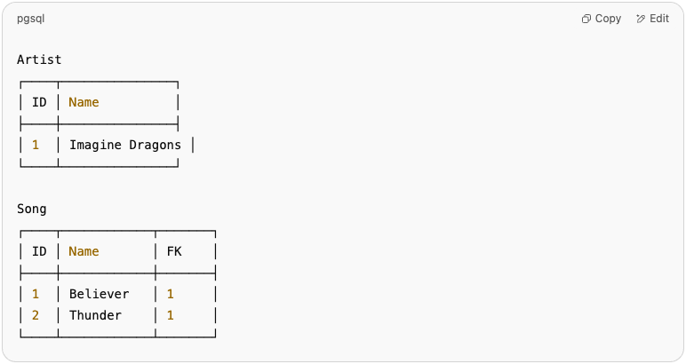

✅ Summary
Topic | What It Means
ORM | Treat DB tables like JavaScript classes
Sequelize | ORM library for Node.js
Models | Define your tables
Migrations | Version control your DB structure
Relationships | Define hasMany, belongsTo, etc.
Benefits | Easy to use, readable, safe, maintainable

